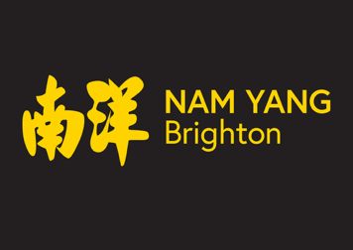

Nam Yang Risk Assessment Policy

Purpose
Nam Yang is committed to providing a safe and supportive environment for all participants, staff, volunteers, and visitors. This policy outlines our approach to identifying, assessing, and managing risks associated with our activities, premises, and services.

Policy Statement
Nam Yang will take all reasonable steps to prevent harm and reduce risk by carrying out regular risk assessments and implementing appropriate control measures. Risk assessments will support the safe delivery of martial arts classes, mindfulness sessions, outreach activities, events, and day-to-day operations.

Responsibilities
- Senior management have overall responsibility for ensuring effective risk management across the charity.
- Senior management will ensure that risk assessments are completed, reviewed, and appropriate actions are taken.
- Staff and volunteers are responsible for following agreed safety procedures and reporting hazards, incidents, or concerns.

Risk Assessment Process
Nam Yang will:
- Identify hazards and potential risks.
- Assess who may be harmed and how.
- Evaluate the likelihood and severity of harm.
- Implement suitable control measures to reduce risk.
- Record significant findings where appropriate.
- Review assessments regularly and whenever activities, locations, or circumstances change.

Review
Risk assessments will be reviewed annually as a minimum, and following any significant incident, near miss, change in activity, or change in relevant legislation or guidance.

Monitoring
Incidents, accidents, and near misses will be recorded and reviewed to identify trends and improve safety practices. This policy will be reviewed by our Wellbeing Trustee at least every three years.

